Implications of Passage of Families First Prevention Services Act

Presenters:
Sean Hughes
Brian Blalock
Angie Schwartz
Cathy Senderling

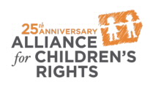

kids-alliance.org

This certifies that attended the 2 hour “Implications of Passage of Families First Prevention Services Act” Webinar Training on April 24, 2018.
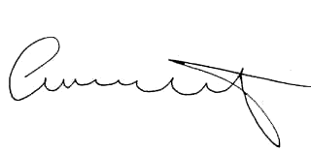

Attendee Signature Angie Schwartz

