Supporting Transition Age Foster Youth in the Child Welfare and Probation Systems

Presenters:
Nisha Kashyap
Leah Gasser-Ordaz
Doniesha Thomas

kids-alliance.org

This certifies that attended the 2 hour “Supporting Transition Age Foster Youth in the Child Welfare and Probation Systems” Webinar Training on March 21, 2018.
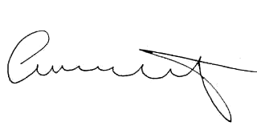

Attendee Signature Angie Schwartz

