From Placement to Permanence: Understanding Options and Valuing Kin

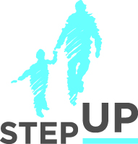
Presenters:
Angie Schwartz
Sue Abrams

Pam Lehtonen

Bob Ruble

stepupforkin.org

This certifies that attended the 2 hour From Placement to Permanence: Understanding Options and Valuing Kin Webinar Training on April 19, 2017.
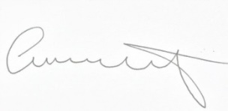

Attendee Signature Angie Schwartz

