Understanding Child and Family Teams and Best Practices for Using CFTs to Engage and Support Children, Youth and Families

Presenters:
Mary Sheppard
Madeline Roachell
Regina Goree
Tim Halbur
Vanessa Hernandez

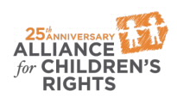

kids-alliance.org

This certifies that attended the 2 hour Understanding Child and Family Teams and Best Practices for Using CFTs to Engage and Support Children, Youth and Families Webinar Training on August 23, 2017.
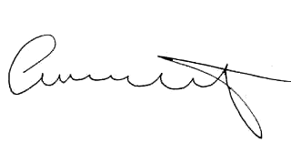

Attendee Signature Angie Schwartz

