Why you need to understand child welfare funding and federal safety net programs

Presenters:
Angie Schwartz
Brian Blalock

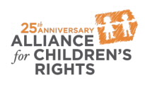

kids-alliance.org

This certifies that attended the 2 hour “Why you need to understand child welfare funding and federal safety net programs” Webinar Training on September 27, 2017.
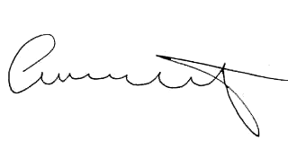

Attendee Signature Angie Schwartz

