All in the Family: Recruiting, Engaging and Supporting Kin

Presenters:
Judge Michael Nash
Jay Kadash
Lisa Chambers
Yakiciwey Mitchell
Tiffany Collins
Jennifer Lopez
Angie Schwartz

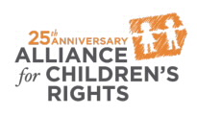

kids-alliance.org

This certifies that attended the 2 hour “All in the Family: Recruiting, Engaging and Supporting Kin” Webinar Training on November 15, 2017.
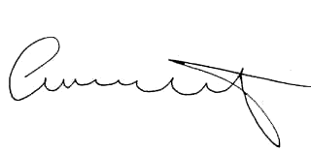

Attendee Signature Angie Schwartz

