The Emergency Child Care Bridge Program: What It Is, How It Works, Why It Matters

Presenters:
Angie Schwartz
Donna Sneeringer
Jeremy Heebner
Diana Boyer

kids-alliance.org

This certifies that attended the 1 hour “The Emergency Child Care Bridge Program: What It Is, How It Works, Why It Matters” Webinar Training on November 17, 2017.
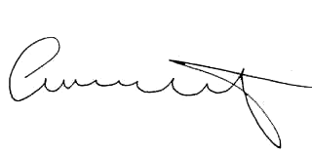

Attendee Signature Angie Schwartz

