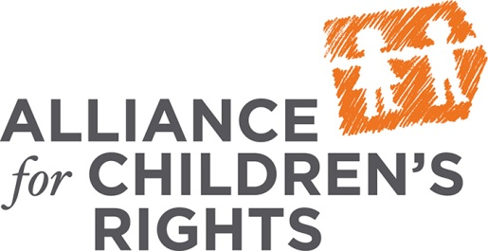
Requesting Regional Center Records:
Step-by-Step Guide

Who is an education rights holder (“ERH”)?
- Biological parents, unless their rights have been limited or terminated by a court
- Adoptive Parents with adoption order
- Legal Guardians with letters of guardianship from a court
- Responsible adults appointed by the court to hold education rights via JV-535 (ex. Foster parents, Relative caregivers, Court Appointed Special Advocates)
The Purpose of Requesting Records
- To track the child’s development over time
- To help better understand the child’s needs
- To determine early intervention services that have or have not worked in the past
Examples of Records You May Receive
- Interdisciplinary (“ID”) notes: These show what actions the service coordinator has taken on the child’s case.
- Evaluations/Assessments: Evaluations review all of the child’s developmental areas (cognitive, communication, physical and motor, adaptive, and social-emotional); Assessments focus on a specific area of concern (i.e., communication) and are used to determine the services the child needs.
- Individualized Family Service Plans (“IFSPs”): These are the plans that include the services necessary to improve the child’s development
Procedures for ERHs to Request Regional Center Records
- Complete the form: Sign and date the form on the reverse side of this document.
- Submit the form: Turn in the completed form and proof that you hold education rights to all the regional centers you’re requesting records from. Proof that you hold education rights may be: a minute order or JV-535 form from the court, guardianship letters or adoption order. If you are the biological parent to the child you DO NOT need to present any proof.
- Get proof: You should get proof that the regional center received your records request, in case you later have any difficulties getting the regional center to send records. There are 3 possible ways to get proof that you submitted the records request form.
    - If submitting the form in person, get a date stamp on the form and keep a copy as proof.
    - If submitting via fax, keep a copy of the fax transmittal report confirming that the fax was received.
    - If sending via mail, send it via certified mail. Make sure to keep the certified mail receipt as proof.
- Get records: regional centers, by law, have only 5 business days to send you the records you requested. You should call the regional center 2 days after submitting the records request form, to confirm that it was received and that they will be sending you records within 5 business days. If the regional center informs you that they do not have records for your child, ask that they put this in writing.
- If by the 5th day you have not received any records, contact the regional center and request that they send them to you immediately.
- Organize and Review Records: Once you receive the records, organize them chronologically and read through them to make sure you received everything you requested. You should make sure that you received all of the child’s evaluations, assessments, IFSPs, Interdisciplinary (“ID”) Notes, referrals, and correspondence between the regional center and the family. If you notice that anything is missing, you should go back to the regional center and request that they give you the missing documents.

Date:

Regional Center Name:

Regional Center Address:

RE: Child’s Name:

Child’s Date of Birth:

Dear Records Clerk,

I request a copy of any and all regional center records for the above mentioned child. I request all records, including, but not limited to the following:

- All ID notes.
- All correspondence between the regional center and the family.
- All referrals sent to the regional center requesting assessment for the Early Start Program.
- All intake documentation.
- All purchase of service agreements/requests for funding.
- All evaluations/assessments conducted by regional center and/or regional center contracting therapists/evaluators/assessors.
- All records, including any and all Individualized Family Service Plans

Please note that I am the education rights holder (“ERH”) for this child. Please waive all fees associated with the duplication of these records, as such fees would effectively deny me access to these records. Please provide a physical copy of all records to the address below. I understand that by law, these records should be provided to me in 5 working days. 17 CCR § 52164(b). Thank you for your attention to this matter. If you have any questions do not hesitate to contact me at your earliest convenience.

ERH Signature:

ERH Name:

ERH Address:

ERH Phone Number:

