2018 California Child Welfare Budget Requests

Presenters:
Anna Johnson
Susanna Kniffen
Amy Lemley
Kim Lewis
Kristin Power
Elise Weinberg

kids-alliance.org

This certifies that attended the 2 hour “2018 California Child Welfare Budget Requests” Webinar Training on May 23, 2018.
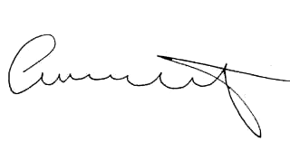

Attendee Signature Angie Schwartz

