Family First Prevention Services Act: Impacts on Transition Age Youth

Presenters:
Brian Blalock
Sean Hughes
Jennifer Pokempner
Angie Schwartz
Cathy Senderling

kids-alliance.org

This certifies that attended the 2 hour “Family First Prevention Services Act: Impacts on Transition Age Youth” Webinar Training on June 22, 2018.
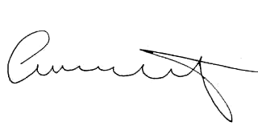

Attendee Signature Angie Schwartz

