Permanency for Our Older Youth

Presenters:
Cynthia Billey
Alliance for Children’s Rights
Lisa Campbell-Motton,
Los Angeles County Probation Department
Jennifer Pokempner
Juvenile Law Center
Gail Johnson Vaughan
Families NOW
Angie Schwartz
Alliance for Children’s Rights

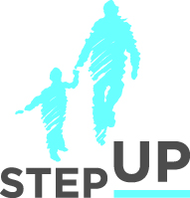

stepupforkin.org

This certifies that attended the 2 hour Webinar Training Permanency for Our Older Youth Webinar on April 19th, 2016.

Attendee Signature Angie Schwartz

