Youth Homelessness in the Era of Extended Foster Care: Lessons for Our Child Welfare System

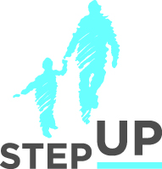
Presenters:

Brian Blalock
Erin Palacios
Reed Connell

stepupforkin.org

This certifies that attended the 2 hour Youth Homelessness in the Era of Extended Foster Care: Lessons for Our Child Welfare System Webinar Training on September 21, 2016.

Attendee Signature Angie Schwartz

