CA Child Advocates for Change:
Informing the National Debate on Child Welfare Reforms

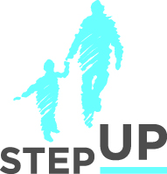
Presenters:

Angie Schwartz
Martha Matthews
Sean Hughes

Emily Putnam-Hornstein

stepupforkin.org

This certifies that attended the 2 hour CA Child Advocates for Change: Informing the National Debate on Child Welfare Reforms Webinar Training on October 19, 2016.

Attendee Signature Angie Schwartz

