Educational Needs of Foster Youth and Youth Experiencing Homelessness – McKinney-Vento, Fostering Connections, ESSA, and Beyond

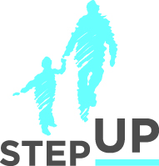
Presenters:
Brian Blalock
Michael Santos

Megan Stanton- Trehan

Sherilyn Adams

stepupforkin.org

This certifies that attended the 2 hour Educational Needs of Foster Youth and Youth Experiencing Homelessness – McKinney-Vento, Fostering Connections, ESSA, and Beyond Webinar Training on March 22, 2017.

Attendee Signature Angie Schwartz

