Ensuring Comprehensive Community-Based Services for Delinquency- Involved Youth

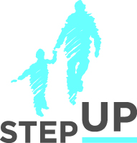
Presenters:
Brian Blalock
Sabrina Forte

Michael Klein

Elise Weinberg

stepupforkin.org

This certifies that attended the 2 hour Ensuring Comprehensive Community-Based Services for Delinquency- Involved Youth Webinar Training on May 24, 2017.

Attendee Signature Angie Schwartz

