Mental Health Care for
Young People in Foster Care

Presenters:
Dr. Robert Byrd
Dr. Kaliah Salas
Brian Blalock
Kevin Jervik

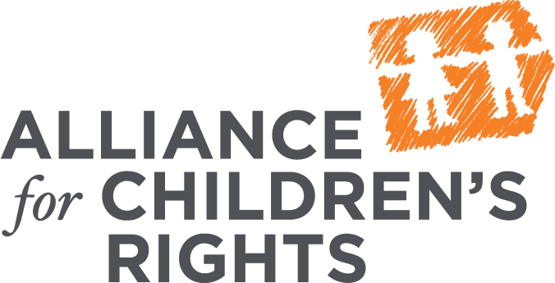

kids-alliance.org

This certifies that attended the 2 hour Mental Health Care for Young People in Foster Care Webinar Training on June 28, 2017.

Attendee Signature Angie Schwartz

