Review of New Child Welfare Laws: 2017 Policy Reforms

Presenters:
Susan Abrams
Brian Blalock
Jessica Haspel
Susanna Kniffen
Debbie Raucher
Angie Schwartz

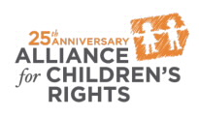

kids-alliance.org

This certifies that attended the 2 hour “Review of New Child Welfare Laws: 2017 Policy Reforms” Webinar Training on October 25, 2017.
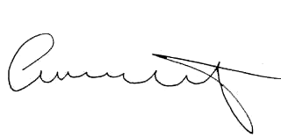

Attendee Signature Angie Schwartz

