Emergency Caregiver Funding: Overview of AB 110 and AB 1811

Presenters:
Sara Rogers
Kim Wrigley

Angie Schwartz
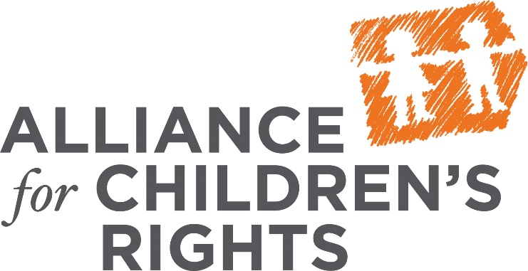

This certifies that attended the 1.5 hour Emergency Caregiver Funding: Overview of AB 110 and AB 1811 Training on July 19, 2018.

Attendee Signature Angie Schwartz

