Indian Child Welfare Act & Resource Family Approval: Family Placement Focus

Presenters:
Kristin Power
Delia M. Sharpe
Elise Weinberg
Marilyn Zhao

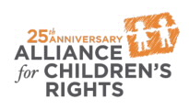

kids-alliance.org

This certifies that attended the 2 hour “Indian Child Welfare Act & Resource Family Approval: Family Placement Focus” Webinar Training on July 25, 2018.
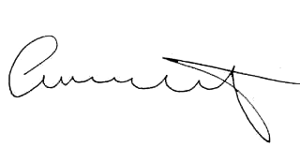

Attendee Signature Angie Schwartz

