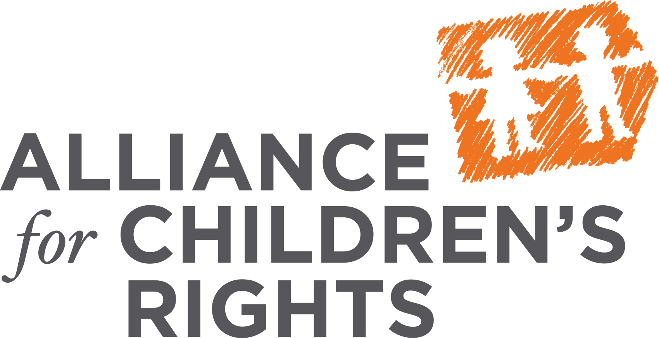
Level of Care Rate Protocol:
Ensuring Foster Care Resources Meet the Assessed Needs of Children

Background

Continuum of Care Reform (CCR) is a system-wide reform designed to ensure that all children in foster care are raised in loving family homes. CCR brings with it sweeping changes to child welfare, including a new child-centered foster care rate system that is based on the assessed needs of the individual child. It is called the Home-Based Family Care Rate System (HBFC) and it includes five levels of care: LOC 1 through 4, plus a specialized Intensive Services Foster Care (ISFC) rate for children with extraordinary needs. This is the first time California has attempted to create a rate based on the child’s needs and, therefore, care must be taken to ensure that the protocol to determine the LOC rate is a reliable and valid tool before we implement it statewide.

While child welfare advocates strongly support the new Level of Care (LOC) system, the LOC Protocol developed by the state to determine which level of care a child will receive adds complexity, inefficiency, and confusion to the already burdensome system of support for children in foster care. Specifically:
- Early testing of the LOC Protocol suggested that the tool is unreliable: when different users score the same child, they often reach different results.

- The LOC Protocol has never been piloted or studied to determine whether the score a child receives aligns with their overall care and supervision needs – in other words, we do not know whether the Protocol is reasonably accurate in determining needs.

- Final guidance has not been issued to inform counties how to integrate the LOC Protocol with existing county-specific specialized care systems. Once such guidance is issued by the state, counties require time to amend their specialized care plans accordingly and train staff on new policies and protocols.

- The Protocol adds to, and does not replace, existing CANS and SCI assessments, increasing county workload in assessing children at the time of placement, and forcing families to navigate multiple and overlapping levels of bureaucracy during the first critical months of placement.

CDSS Agreement to Further Study and Analysis of the LOC Protocol Prior to Full Implementation

In January, CDSS agreed to delay statewide implementation of the new LOC Protocol to May 1st, promising to:
- phase-in the full implementation of the tiered rates and the LOC Protocol, beginning with new entries into Foster Family Agency (FFA) placements starting March 1st;

- contract with researchers to study more thoroughly the new assessment tool during the initial phase-in with the FFAs, and, specifically, both its accuracy in scoring youth with higher needs appropriately, and its reliability when used by different evaluators to score the same youth.

- make necessary changes to the LOC Protocol prior to statewide implementation and allow counties sufficient time to adapt to those changes and train staff.
It is now clear that it is not possible for CDSS to complete the deliverables promised prior to the intended May 1 statewide implementation date:
- The study currently underway did not begin until mid-March and there will be very little data to review and almost no time to make necessary improvements by May 1.

- Due to the limited amount of time for the study, it has been limited to a review of reliability among users and there will be no attempt to study the accuracy of the LOC Protocol by May 1 or refine the LOC Protocol.

- Counties will not have time to make changes to their existing protocols and policies, train staff, develop notifications of changes, and inform families.

The FFA rollout provides ample opportunity to observe the LOC Protocol in action, evaluate its veracity, reliability and accuracy, and identify gaps that need to be addressed prior to statewide rollout. In the meantime, counties may train staff, update their own protocols and practices, and make adjustments and refinements prior to statewide rollout. CDSS has not fulfilled its promised deliverables and more time needs to be allotted for these critical activities. Under the status quo, relatives, non-related extended family members and county homes lose nothing as they continue to have access to specialized care rates (which are not currently available in FFA placements). Disrupting the existing rates system without time to develop the new specialized rates plans and implementing the new LOC system before it is fully piloted will result in relatives and extended family members experiencing backlog, delay, and receiving erroneous assessments leading to placement disruptions and undue stress on families.

Solution

We encourage the Legislature to ensure the following occurs prior to moving forward with implementation of the LOC Protocol statewide:
- Continue to pilot the LOC Protocol through a formal process to demonstrate reliability among users and expand the pilot to study its accuracy in assessing a child’s needs.

- Revise the LOC Protocol in response to the veracity and reliability studies.

- Ensure that CDSS has issued final written guidance on how to revise county specialized care increment programs

- Afford counties sufficient time to train staff and revise local practices and protocols.

- Require that counties demonstrate readiness through certification that the county has hired and trained necessary staff, been afforded adequate time to make adjustments to their specialized care programs, finalized written procedures to implement LOC, and conducted necessary outreach to caregivers to inform them about the new rate system.

