Supporting Youth and Families through Child and Family Teams

Presenters:
Katarina Kabick
Manuel Lua
Pam Meeker
Lisa Witchey
Elise Weinberg

kids-alliance.org

This certifies that attended the 2 hour “Supporting Youth and Families through Child and Family Teams” Webinar Training on August 29, 2018.
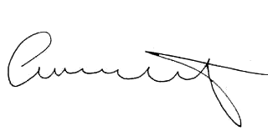

Attendee Signature Angie Schwartz

