New Child Welfare Laws: 2018 Policy Reforms

Presenters:
Susan Abrams
Anna Johnson
Amy Lemley
Angie Schwartz
Cathy Senderling-McDonald

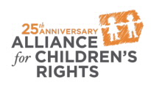

kids-alliance.org

This certifies that attended the 2 hour “New Child Welfare Laws: 2018 Policy Reforms” Webinar Training on October 31, 2018.
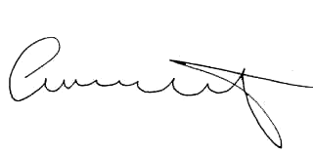

Attendee Signature Angie Schwartz

