Interstate Compact on Placement of Children: Ensuring Adequate Protection & Support Services Across State Lines

Presenters:
Angie Schwartz
Ronnie Cheung
Christina Libre

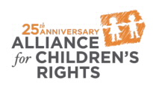

kids-alliance.org

This certifies that attended the 1.5 hour “Interstate Compact on Placement of Children: Ensuring Adequate Protection & Support Services Across State Lines” Webinar Training on December 5, 2018.
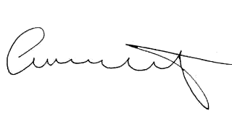

Attendee Signature Angie Schwartz

