Increasing Access to Emergency Child Care Bridge Program

Presenters:
Domenica Benitez
Michael Fleming
Susanna Kniffen
Lodia Ruiz
Tracy Urban
Andria Zaverl

kids-alliance.org

This certifies that attended the 1.5 hour “Increasing Access to Emergency Child Care Bridge Program” Webinar Training on March 27, 2019.
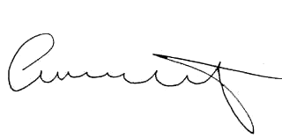

Attendee Signature Angie Schwartz

