Latest Updates to the Continuum of Care Reform (CCR)

Presenters:
Susan Abrams
Dr. Denise Goodman
Lesia Knudsen
Sara Rogers
Jordan Sosa
Gail Johnson Vaughan
Kim Wrigley

kids-alliance.org

This certifies that attended the 2 hour “Latest Updates to the Continuum of Care Reform” Webinar Training on May 22, 2019.
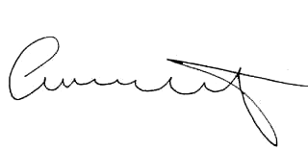

Attendee Signature Angie Schwartz

