School and Placement Stability: Determining Best Interest for Children in Foster Care

Presenters:
Dean Conklin
Alaina Moonves-Leb
Jordan Sosa

kids-alliance.org

This certifies that attended the 2 hour “School and Placement Stability: Determining Best Interest for Children in Foster Care” Webinar Training on June 26, 2019.
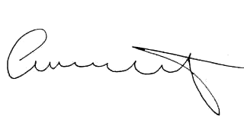

Attendee Signature Angie Schwartz

