Family First: Responding to the Shifting Landscape of Child Welfare

Presenters:
Angie Schwartz
Brian Blalock
Cathy Senderling
Mark Mecum
Sarah Helevy
Sean Hughes

kids-alliance.org

This certifies that attended the 2.5 hour “Family First: Responding to the Shifting Landscape of Child Welfare” Webinar Training on July 31, 2019.
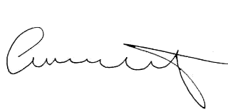

Attendee Signature Angie Schwartz

