Back to School: Preparing Foster Youth for School Year Success

Presenters:
Alaina Moonves-Leb
Kawena Cole
Camille Bailey

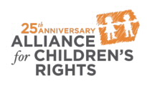

kids-alliance.org

This certifies that attended the 2 hour “Back to School: Preparing Foster Youth for School Year Success” Webinar Training on August 21, 2019.

Attendee Signature Angie Schwartz

