Preparing Families for Permanency in the Context of Resource Family Approval

Presenters:
Kelsey Dahlin, ACSW
Carol Ramirez, LCSW
Terese
Charm Lee
Christina DeSmet
Lisa Wetzel
Cynthia Billey

kids-alliance.org

This certifies that attended the 2 hour “Preparing Families for Permanency in the Context of Resource Family Approval” Webinar Training on September 25, 2019.
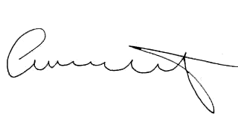

Attendee Signature Angie Schwartz

