2019 New Laws & Budget Allocations: Supporting Youth in Foster Care

Presenters:
Kristin Power
Susanna Kniffen
Amy Lemley
Susan Abrams
Dafna Gozani

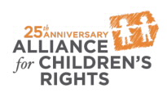

kids-alliance.org

This certifies that attended the 2 hour “2019 New Laws & Budget Allocations: Supporting Youth in Foster Care” Webinar Training on October 30, 2019.
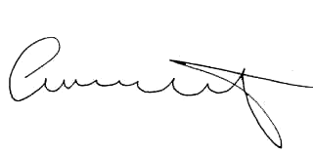

Attendee Signature Angie Schwartz

