Exploring the Office of the Ombudsperson for Foster Care and the Foster Youth Bill of Rights

Presenters:
Rochelle Trochtenberg

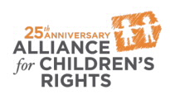

kids-alliance.org

This certifies that attended the 2 hour “Exploring the Office of the Ombudsperson for Foster Care and the Foster Youth Bill of Rights” Webinar Training on January 15, 2020.
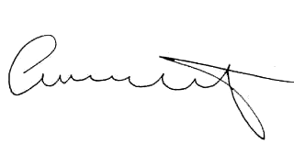

Attendee Signature Angie Schwartz

