Hidden Foster Care: The Human Impact of Bypassing Foster Care for At-Risk Children

Presenters:
Angie Schwartz
Josh Gupta-Kagan
Carolyn Griesemer
Linda Leighton
Ana Lora

kids-alliance.org

This certifies that attended the 2 hour “Hidden Foster Care: The Human Impact of Bypassing Foster Care for At-Risk Children” Webinar Training on March 18, 2020.
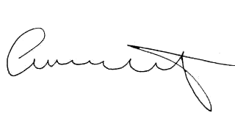

Attendee Signature Angie Schwartz

