Overview of New Laws and Policies to Support Foster Youth and Families Impacted by COVID-19

Presenters:
Diana Boyer
Corrin Buchanan
Valerie Earley
Alexis Fernández
Jeremy Heebner
Leslie Heimov
Sara Rogers
Angie Schwartz
Cathy Senderling

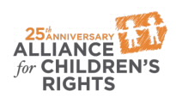

kids-alliance.org

This certifies that attended the 2 hour “Overview of New Laws and Policies to Support Foster Youth and Families Impacted by COVID-19” Webinar Training on April 16, 2020.
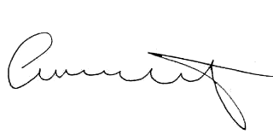

Attendee Signature Angie Schwartz

