Advocating for Special Education Needs: Best Practices to Support Children in a Time of Crisis

Presenters:
Marisol Garcia
Mark Rodgers
Jill Rowland
Angie Schwartz

kids-alliance.org

This certifies that attended the 2 hour “Advocating for Special Education Needs: Best Practices to Support Children in a Time of Crisis” Webinar Training on April 30, 2020.
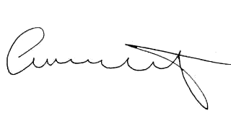

Attendee Signature Angie Schwartz

