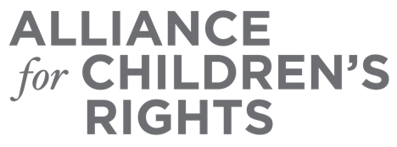

CERTIFICATE OF COMPLETION

2020 Learning Continuity and Attendance Plan: Recommendations for Schools and Stakeholders to Support Students with Unique Needs

Presenters:

Deborah Avalos
Heidi Brahms
Atasi Uppal
Megan Stanton-Trehan
Kate Teague
Danielle Wondra
Mark Rodgers Rodgers
RaDene Girola
Angie Schwartz

This certifies that attended the 1.5 hour “2020 Learning Continuity and Attendance Plan: Recommendations for Schools and Stakeholders to Support Students with Unique Needs” Webinar Training on August 27, 2020.

Attendee Signature Angie Schwartz
VP, Policy and Advocacy
Alliance for Children’s Rights

