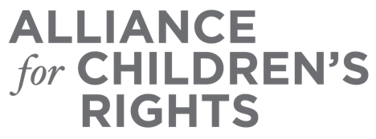

CERTIFICATE OF COMPLETION

Accessing Mental Health Resources
in a Time of Crisis

Presenters:

Michelle Cabrera
Gail DiRaimondo
Molly Kholos
Robert Byrd
Veronica Macias
Kim Suderman
Angie Schwartz

This certifies that attended the 2 hour “Accessing Mental Health Resources in a Time of Crisis” Webinar Training on July 9, 2020.

Attendee Signature Angie Schwartz
VP, Policy and Advocacy
Alliance for Children’s Rights

