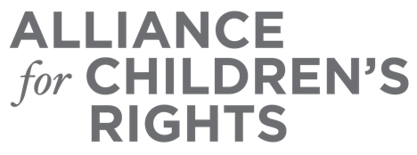

CERTIFICATE OF COMPLETION

The Latest Updates on the Family First Prevention Services Act (FFPSA) and Washington State's Implementation Plan

Presenters:

Sean Hughes
Rachel Mercer
Steven Grilli
Vickie Ybarra
Angie Schwartz

This certifies that attended the 1.5 hour “The Latest Updates on the Family First Prevention Services Act (FFPSA) and Washington State's Implementation Plan” Webinar Training on September 14, 2020.

Attendee Signature Angie Schwartz
VP, Policy and Advocacy
Alliance for Children’s Rights

